**Kulvir Singh**

**19BCE2074**

**Experiment 2 (15.02.2020)**

*Question 1*

***Problem Statement :***

Use scrapy to crawl any one of the E-commerce websites of your choice and perform the same. The following information needs to be extracted from the page: (Choose any one product: e.g. laptop, smartphone … etc.)

a)Product name

b)Product price

c)Product discount

d)Product image

***Procedure :***

Tools Used: Scrapy packages, python, ide to run the program, terminal/cmd (scrappy shell) for execution of various commands

Steps for Implementation:

1. Install the scrapy packages (pip install scrappy)

2. Create a new scrapy project (scrapy startproject [projectname])

3. Generate a spider to crawl through the web pages

4. Configure/edit the settings.py and the spider files as per requirement.

5. Run the program using ide and cmd to obtain results.

***Code :***

***items.py***

import scrapy

class ProductsItem(scrapy.Item):

# define the fields for your item here like:

product_name = scrapy.Field()

product_price = scrapy.Field()

product_discount = scrapy.Field()

product_image = scrapy.Field()

***flipkart_spider.py***

import scrapy

from ..items import ProductsItem

class pro(scrapy.Spider):

name = "pro"

start_urls = ["https://www.flipkart.com/samsung-galaxy-m21-midnight-blue-128-gb/p/itm0cec19c31b3cb?pid=MOBFSF85ZMVH3ZMG&lid=LSTMOBFSF85ZMVH3ZMGHVRMDR&marketplace=FLIPKART&fm=neo%2Fmerchandising&iid=M_ab883bcf-9673-4bf2-adc9-fccdcf6198a4_1_1BUWY8OBA8L9_MC.MOBFSF85ZMVH3ZMG&ppt=clp&ppn=samsung-mobile-store&ssid=0lzd5i7qgw0000001596104962790&otracker=clp_pmu_v2_Latest%2BSamsung%2Bmobiles%2B_1_1.productCard.PMU_V2_Latest%2BSamsung%2Bmobiles%2B_samsung-mobile-store_MOBFSF85ZMVH3ZMG_neo%2Fmerchandising_0&otracker1=clp_pmu_v2_PINNED_neo%2Fmerchandising_Latest%2BSamsung%2Bmobiles%2B_LIST_productCard_cc_1_NA_view-all&cid=MOBFSF85ZMVH3ZMG"]

def parse(self,response):

product_name=response.css("span.B_NuCI::text").extract()

product_price=response.css("div._30jeq3._16Jk6d::text").extract()

product_discount=response.css("div._3Ay6Sb._31Dcoz").css("span::text").extract()

product_image=response.css("div.q6DClP::attr(style)").extract()

items=ProductsItem()

items["product_name"]=product_name

items["product_price"]=product_price

items["product_discount"]=product_discount

items["product_image"]=product_image

yield items

***Code Screenshot:***

***items.py***

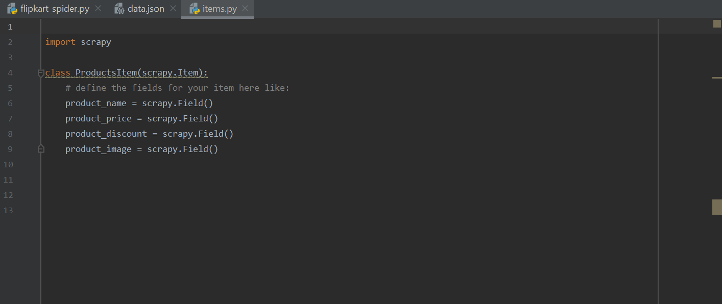

***flipkart_spider.py***

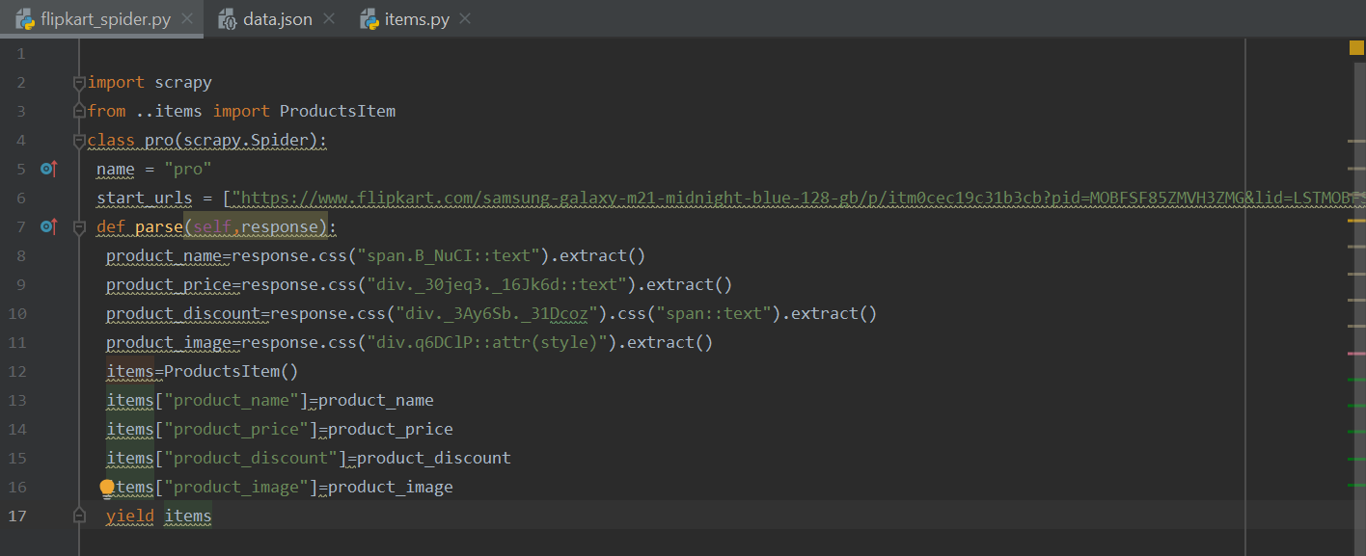

***Output Screenshots :***

data.json

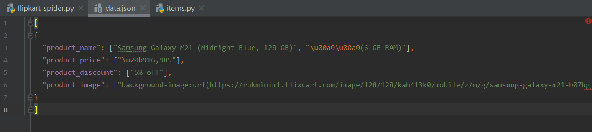

***data.json:***

[

{

"product_name": ["Samsung Galaxy M21 (Midnight Blue, 128 GB)", "\u00a0\u00a0(6 GB RAM)"],

"product_price": ["\u20b916,989"],

"product_discount": ["5% off"],

"product_image": ["background-image:url(https://rukminim1.flixcart.com/image/128/128/kah413k0/mobile/z/m/g/samsung-galaxy-m21-b07hgjj55il-original-imafsfewggf3dqwc.jpeg?q=70)", "background-image:url(https://rukminim1.flixcart.com/image/128/128/kah413k0/mobile/z/m/g/samsung-galaxy-m21-b07hgjj55il-original-imafsfewptm9vmsb.jpeg?q=70)", "background-image:url(https://rukminim1.flixcart.com/image/128/128/kah413k0/mobile/z/m/g/samsung-galaxy-m21-b07hgjj55il-original-imafsfewxhmhptvw.jpeg?q=70)", "background-image:url(https://rukminim1.flixcart.com/image/128/128/kah413k0/mobile/z/m/g/samsung-galaxy-m21-b07hgjj55il-original-imafsfewyghchvfy.jpeg?q=70)", "background-image:url(https://rukminim1.flixcart.com/image/128/128/kah413k0/mobile/z/m/g/samsung-galaxy-m21-b07hgjj55il-original-imafsfgtjwa5vmgf.jpeg?q=70)", "background-image:url(https://rukminim1.flixcart.com/image/128/128/kah413k0/mobile/z/a/w/samsung-galaxy-m21-b07hgjj559-original-imafsfgtgxhpzpfr.jpeg?q=70)", "background-image:url(https://rukminim1.flixcart.com/image/128/128/kah413k0/mobile/z/m/g/samsung-galaxy-m21-b07hgjj55il-original-imafsfgtx2gty9tu.jpeg?q=70)"],

}

]